Grammar for ast

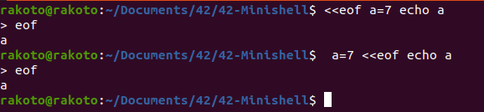
cmd → (HEREDOC)* (assign)* cmd_name (HEREDOC)* (redir)* (args)*

not that heredoc and assign can change place

heredoc , redir and args can change place and can sandwitch

Note also that heredoc before cmd is executed first

if want to treat trailing pipe, note that we handle heredoc first then take the remaining cmd

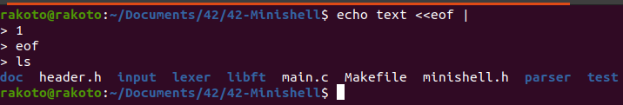
same if heredoc before cmd_name

but one real question is that does heredoc still executed when kind of error ?

Grammar

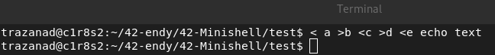

cmd → (HEREDOC)* (assign)* (redir)* cmd_name (HEREDOC)* (redir)* (args)* (assign = args)*

pipeline → cmd (| cmd)*

to do

- cmd structure
. char **args
. t_list *assign
use ft_lstaddback,
. t_list *redir
use ft_lstaddback,
- create cmd
- free cmd

- parse cmd
- parse cmd

